Supplementary material
Fig S1: The purity and the structure of MOTS-c were checked by mass spectrometryc and analytical HPLC. Both the purity and structure of MOTS-c peptide reached the experimental requirement.

Fig S2: The purity and the structure of FITC-MOTS-c were checked by mass spectrometryc and analytical HPLC. Both the purity and structure of FITC-MOTS-c peptide reached the experimental requirement.

Fig S3: The purity and the structure of Rho-MOTS-c were checked by mass spectrometryc and analytical HPLC. Both the purity and structure of Rho-MOTS-c peptide reached the experimental requirement.

Fig S4: The purity and the structure of Rho-MP were checked by mass spectrometryc and analytical HPLC. Both the purity and structure of Rho-MP peptide reached the experimental requirement.

Fig S5: The purity and the structure of MP were checked by mass spectrometryc and analytical HPLC. Both the purity and structure of MP peptide reached the experimental requirement.
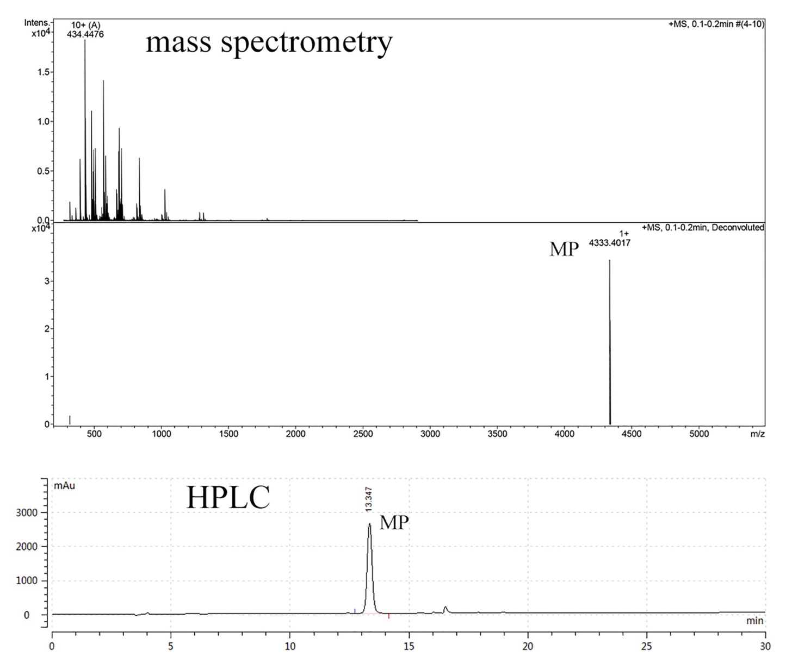

Fig S6: The purity and the structure of FITC-TAT were checked by mass spectrometryc and analytical HPLC. Both the purity and structure of FITC-TAT peptide reached the experimental requirement.

Fig S7: The purity and the structure of FITC-(PRR)₅ were checked by mass spectrometryc and analytical HPLC. Both the purity and structure of FITC-(PRR)₅ peptide reached the experimental requirement.

Fig S8: The purity and the structure of FITC-Antp were checked by mass spectrometryc and analytical HPLC. Both the purity and structure of FITC-Antp peptide reached the experimental requirement.

Fig S9: The purity and the structure of FITC-T7 were checked by mass spectrometryc and analytical HPLC. Both the purity and structure of FITC-T7 peptide reached the experimental requirement.

Fig S10: The purity and the structure of FITC-PTD4 were checked by mass spectrometryc and analytical HPLC. Both the purity and structure of FITC-PTD4 peptide reached the experimental requirement.

Fig S11: The purity and the structure of FITC-HOAX13 were checked by mass spectrometryc and analytical HPLC. Both the purity and structure of FITC-HOAX13 peptide reached the experimental requirement.

Fig S12: The purity and the structure of FITC-(PRR)₃ were checked by mass spectrometryc and analytical HPLC. Both the purity and structure of FITC-(PRR)₃ peptide reached the experimental requirement.

Fig S13: The purity and the structure of FITC-SynB3 were checked by mass spectrometryc and analytical HPLC. Both the purity and structure of FITC-SynB3 peptide reached the experimental requirement.

Fig S14: Confocal microscopy images of BV2 cells incubated with saline, FITC and FITC labeled MOTS-c at doses of 10 µM.
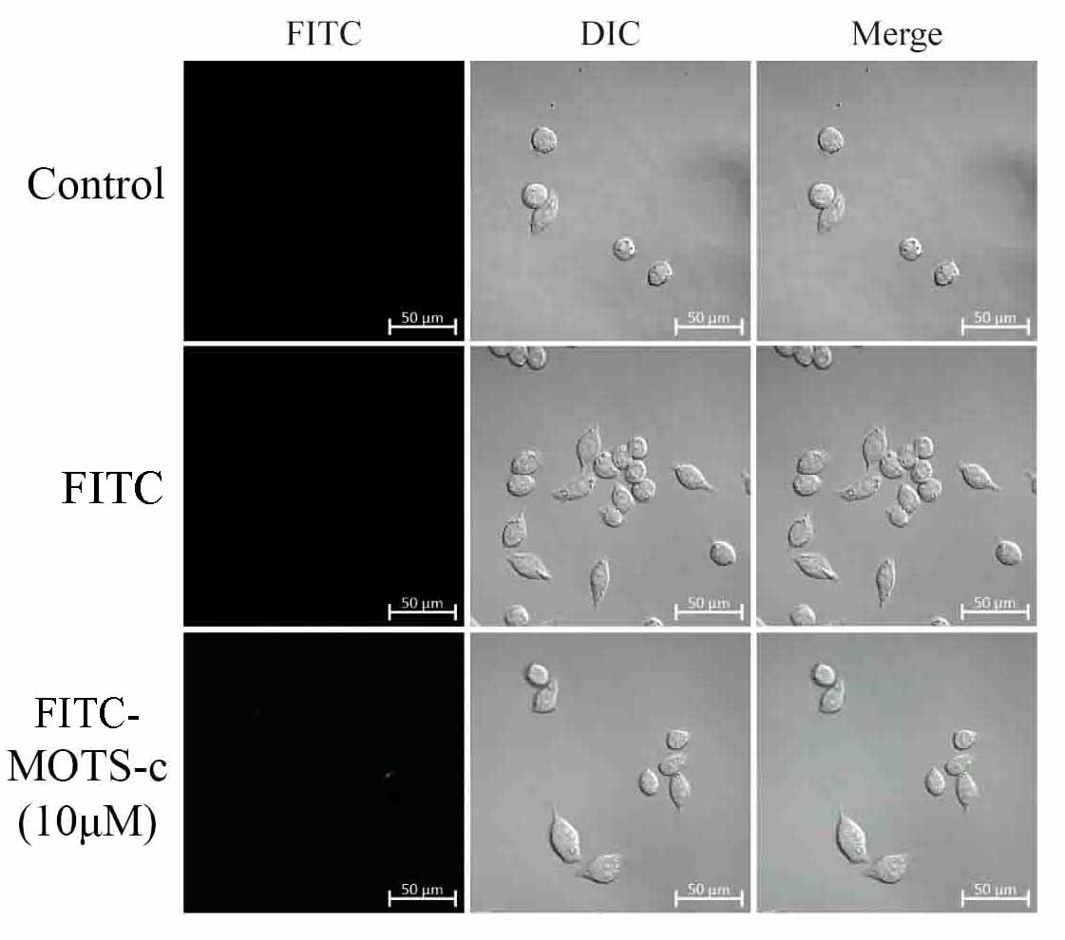

Fig S15: Confocal microscopy images of U87 cells incubated with saline, FITC and FITC labeled MOTS-c at doses of 10 µM.
